Terms of Reference
Annual Impact Measurement (AIM).
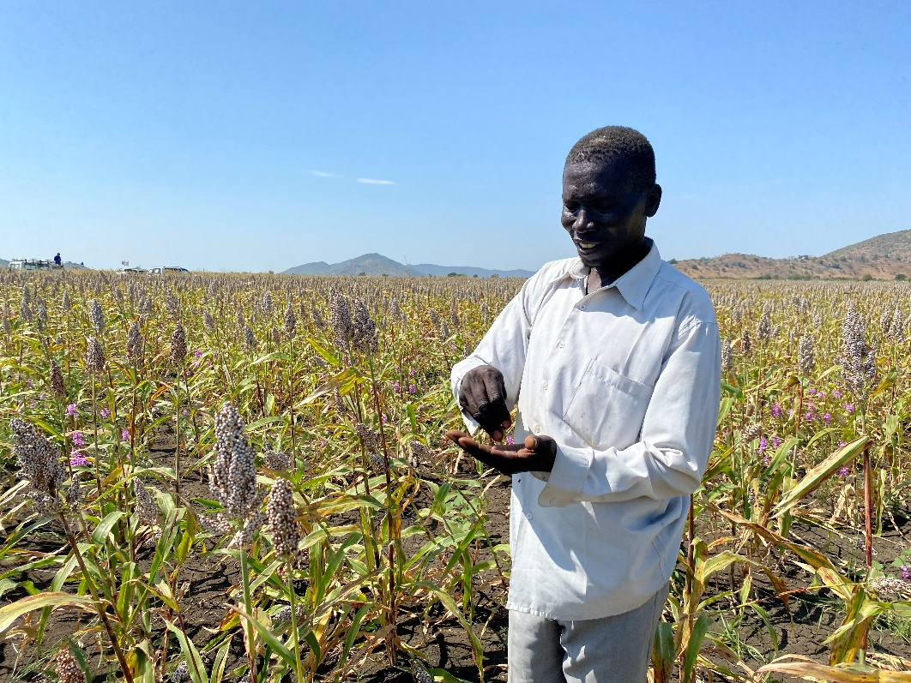

World Vision Sudan

February 2026

- Background
The Annual Impact Measurement (AIM) aims to assess the annual impact of World Vision programs across various Field Offices (FOs) by standardizing assessment methodology and the level 1 OIOS indicators. The study uses a structured approach to help understand the impact of World Vision's interventions aimed at improving child well-being in the communities we serve.

  - Introduction.
World Vision began operations in Sudan during the humanitarian crisis in the Darfur region in June 2004. Currently, World Vision Sudan has operations within seven (7) states namely; South Darfur, South Kordofan, Blue Nile, East Darfur and most recently has expanded into Red Sea (Port Sudan), River Nile and White Nile States.

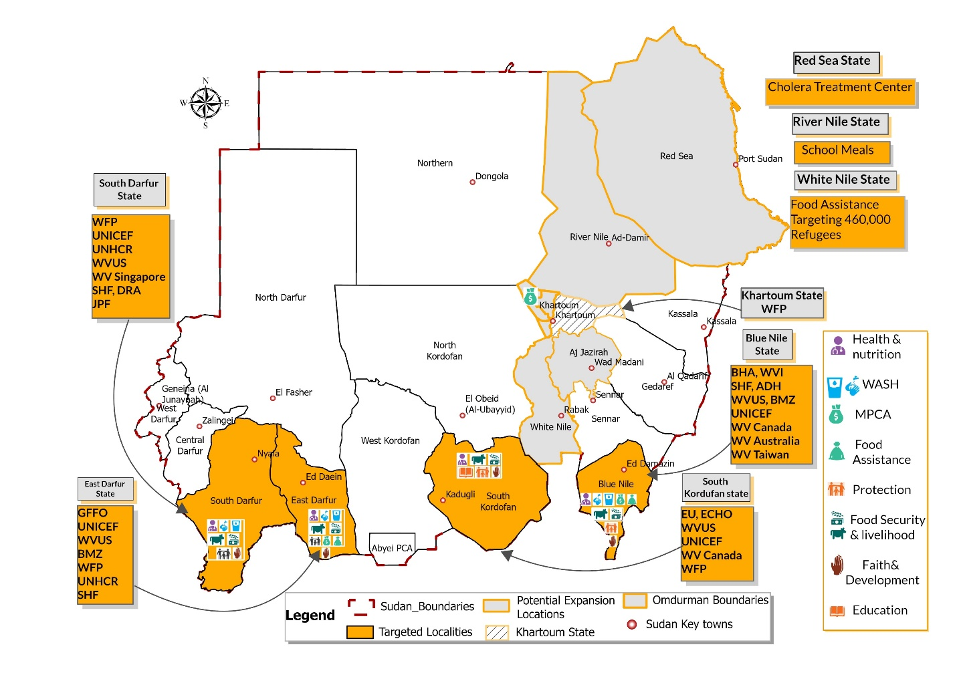
Figure 1: World Vision Operational Map in Sudan.
- Background
The Annual Impact Measurement (AIM) aims to assess the annual impact of World Vision programs across various Field Offices (FOs) by standardizing assessment methodology and the level 1 OIOS indicators. The study uses a structured approach to help understand the impact of World Vision's interventions aimed at improving child well-being in the communities we serve.

  - Key Objective of AIM assessment
The AIM helps measure World Vision Sudan's program and its contribution to meaningful and positive changes. It also assists in validating Our Impact Our Story (OIOS) indicators. Additionally, it will measure WV strategy realization, including programmatic trends. AIM can help identify World Vision's program and operational challenges, as well as create opportunities to leverage World Vision's program in Sudan.

  - Specific Objectives
- To track the annual performance of the World Vision program in achieving child well-being objectives.
- The AIM assessment aims to measure Level 1 (L1) and Level 2 (L2) indicator values and assess any changes in their performance compared to FY25 AIM values.
- To inform program and intervention-level adaptations based on AIM assessment findings.

- Methodology
The AIM assessment will employ primary data collection methods to measure 20 Level 1 (L1) and 5 Level 2 (L2) OIOS indicators across four states: South Darfur, East Darfur, South Kordofan, and Blue Nile. The assessment will follow the standardized AIM methodology provided by World Vision Global Centre (GC) to ensure consistency, comparability, and adherence to OIOS indicator definitions.
Primary data will be collected using two standardized survey tools in line with AIM guidance: (1) the Household Survey Tool, and (2) the Faith Leader Survey Tool. The Household Survey Tool is structured into three modules to capture indicators at different levels within sampled households; Caregiver Module, an Adolescent Module (12–18 years), and a Household Module. This structure enables the measurement of age-specific, gender-specific, and household-level indicators within the same assessment framework. The Faith Leader Survey Tool will be administered separately to selected faith leaders to measure indicators related to spiritual nurture and positive social norms influencing child well-being.
The quantitative component of the assessment will be designed to produce representative estimates at aggregated level, using a 95% confidence level and 5% margin of error in accordance with GC AIM standards. Data collection will be led by an external consultant in coordination with World Vision Sudan MEAL team and will include rigorous enumerator training, supervision, and real-time data quality monitoring, with technical oversight from the GC MEAL team. The AIM data collection process will ensure alignment with standardized OIOS definitions, methodological rigor, and comparability of results across World Vision national offices
  - List of indicators for AIM FY26
The table below outlines the 20 L1 and 5 L2 OIOS indicators to be measured through the standardized AIM survey tools.
OIOS Code | Indicator description | Measurement
6 | Proportion of boys and girls (12-18 years) with positive and peaceful relations with their Parent(s)/Caregiver(s) | Household survey- Adolscent
7 | Proportion of boys and girls (12-18 years) with positive and peaceful relations with their peers | Household survey- Adolscent
26 | Proportion of adolescents engaged in child labour | Household survey- Adolscent
27 | Proportion of adolescents who are married | Household survey- Adolscent
31 | Proportion of children exclusively breastfed until 6 months of age | Household survey- Caregiver
35 | Proportion of infants whose births were attended by a skilled birth attendant | Household survey- Caregiver
38 | Proportion of under 5 (U5) with diarrhoea who received effective treatment of diarrhea | Household survey- Caregiver
160 | Prevalence of underweight in children under five years of age | Household survey- Caregiver
19 | Proportion of children aged 0–59 months whose birth were registered | Household survey- Caregiver
C1A.0008 | Prevalence of stunting in children under 5 years of age (U5) | Household survey- Caregiver
C1A.0018 | Prevalence of wasting in children under 5 years of age (U5) | Household survey- Caregiver
C1B.24765 | Proportion (%) of children (0-59 months) who slept under an insecticidal treated net (ITN) the previous night | Household survey- Caregiver
49 | Proportion of children 3-18 years accessing learning during emergencies | Household survey- Caregiver
26 | Proportion of adolescents engaged in child labour | Household survey- Caregiver
36 | Proportion of mothers who have an Antenatal care (ANC) card that reports, or if no card, if they report that they had eight or more antenatal visits while they were pregnant with their youngest child. | Household survey- Caregiver
C3B.027724 | Proportion (%) of people using hygiene items (Kits) in emergency settings | Household survey- Caregiver
C3B.028108 | Proportion (%) of community members who can recall target health messaging | Household survey- Caregiver
63 | Proportion of households with alternative and risk diversified sources of income | Household survey- Household
65 | Proportion of households with improved access to livelihood support services | Household survey- Household
69 | Proportion of households who are food insecure according to the Coping Strategies Index | Household survey- Household
72 | Proportion of households reporting to have access to sufficient sources of credit providers | Household survey- Household
79 | Proportion of households living in multidimensional poverty | Household survey- Household
96 | Proportion of households using basic drinking water services | Household survey- Household
97 | Proportion of households using basic sanitation services | Household survey- Household
C1B.0110 | Proportion (%) of households using unimproved drinking water who use an appropriate treatment method | Household survey- Household
144 | Proportion of Direct Participant Faith Leaders who took action to influence positive social norms for child well-being | Faith leaders assessment tool

  - Assessment locations and sample size
The AIM Assessment will be conducted across World Vision Sudan operational areas in four 4) states i.e. South Darfur, East Darfur, South Kordofan, and Blue Nile. Localities were selected to reflect the geographic distribution and programmatic presence of World Vision interventions within each state. Sampling was conducted at Country Office level in close coordination with the World Vision Global Centre (GC) MEAL team, following the standardized AIM methodology applied across the partnership.
Given that AIM measures indicators at different levels (adolescents, caregivers, households and faith leaders), separate samples will be drawn for each category to ensure alignment with the respective indicator sets. The first sample will include adolescents and caregivers targeting 8210 respondents that will be interviewed in the four (4) states to measure indicators related to infants, children, adolescent and caregivers well-being, self-efficacy, spiritual nurture, and other outcomes. The distribution is as follows; South Darfur (4,052), East Darfur (1492), South Kordofan (1711), and Blue Nile (955).
For the household-level indicators 643 households will be interviewed to measure indicators related to WASH, food security, economic resilience, multidimensional poverty, disaster recovery, and access to services. The state-level distribution includes South Darfur (317 households), East Darfur (117), South Kordofan (134), and Blue Nile (75). One eligible adult respondent, typically the household head or primary caregiver, will respond to household-level questions on behalf of the household.
In addition, the faith leader component will include 384 faith leaders purposively selected from World Vision-supported communities to assess indicators related to spiritual nurture and positive social norms influencing child well-being. The distribution is South Darfur (189), East Darfur (70), South Kordofan (80), and Blue Nile (45).
Sample size determination for the household and individual components follows World Vision GC AIM standardized sampling matrix (annexed) using a 95% confidence level and 5% margin of error at aggregated level.
Table 3: Sampling matrix, AIM Assessment
State | Locality (ies) | #Respondents | HHs | #Faith leaders
South Darfur |  | 4052 | 317 | 189
 | Nyala Shamal | 270 | 21 | 13
 | Nyala Janoub | 270 | 21 | 13
 | Um Dafug | 270 | 21 | 13
 | Alradum | 270 | 21 | 13
 | Mershing | 270 | 21 | 13
 | Nitega | 270 | 21 | 13
 | Kass | 270 | 21 | 13
 | Buram | 270 | 21 | 13
 | Rehed Aberdi | 270 | 21 | 13
 | Shataya | 270 | 21 | 12
 | Alsunta | 270 | 21 | 12
 | East Marra | 270 | 21 | 12
 | Katella | 270 | 21 | 12
 | Kubung | 270 | 21 | 12
 | Ed-lfursan | 270 | 21 | 12
East Darfur |  | 1492 | 117 | 70
 | Ad Dein | 166 | 13 | 7
 | Adila | 166 | 13 | 7
 | Al Firdous | 166 | 13 | 7
 | Abu Karinka | 166 | 13 | 7
 | Assalaya | 166 | 13 | 8
 | Abu Jabra | 166 | 13 | 8
 | Shia'ria | 166 | 13 | 8
 | Yassin | 166 | 13 | 8
 | Bahr al Arab | 166 | 13 | 10
South Kordofan |  | 1711 | 134 | 80
 | Kadugli | 72 | 13 | 7
 | Abu Kershola | 72 | 13 | 7
 | Abassiya | 72 | 13 | 7
 | Abujubeiha | 72 | 13 | 7
 | Al Goz | 76 | 13 | 10
 | Al Liri | 72 | 13 | 7
 | Rashad | 72 | 13 | 7
 | Dilling | 72 | 13 | 7
 | Talodi | 72 | 13 | 7
 | Ghadeer | 72 | 13 | 7
Blue Nile Region |  | 955 | 75 | 45
 | Blue Nile- Ad Damazin | 159 | 6 | 7
 | Blue Nile- Al Kurmuk | 159 | 6 | 8
 | Blue Nile- Ar Roseires | 159 | 6 | 7
 | Blue Nile- Tadamon | 159 | 6 | 8
 | Blue Nile- Bau | 159 | 6 | 7
 | Blue Nile- Qeissan | 159 | 7 | 8

- Assessment Schedule.
The AIM FY26 assessment will be implemented through a phased workplan covering preparation, field implementation, analysis, and reporting. The table below presents the key activities, milestones, responsible teams, timelines, and current status.
Activity | Milestones | Category | Responsible | Start | Status
Mapping of WV Sudan Country office Indicators for AIM | Approved AIM List of Indicators | Indicator mapping & sampling | WVS MEAL | 31st Jan 2026 | Completed
Mapping Locations (Sates & Localities) for AIM Assessment | Approved List of Indicators for AIM | Field Transformation for DME | WVS MEAL | 31st Jan 2026 | Completed
Finalize sampling table for selected OIOS Indicators for AIM | Sample size & sampling Table | Indicator mapping & sampling | WVS MEAL | 31st Jan 2026 | Completed
Finalize the TOR including the budget | Final Approved TOR | Planning & logistics | WVS MEAL | 15th Feb 2026 | Completed
Engagement with internal stakeholders including technical teams & SPQE Director | WV Sudan Internal AIM Engagement Forum | Planning & logistics | WVS MEAL | 29th April 2026 | Completed
AIM Assessment Security Plan & Approvals | AIM Assessment Security Approval | Planning & logistics | WVS MEAL | 5th May 2026 | Pending
HAC/ SARHO Approval for AIM Assessment Data Collection | AIM Assessment HAC Approval | Planning & logistics | WVS MEAL | 5th May 2026 | Pending
Identification & Recruitment of enumerators for AIM | AIM Enumeretors hired | Field Transformation for DME | WVS MEAL | 5th May 2026 | Pending
Training of Enumeretors for AIM Assessment | Trained Enumeretors on AIM Data collection tools | Data collection | Consultant | 14th May 2026 | Pending
Data Collection for the AIM Assessment | AIM Data | Data collection | Consultant | 31st May 2026 | Pending
AIM Data Analysis | AIM Analyzed data | Learning | Consultant | 5th April 2026 | Pending
AIM- WV Sudan draft reporting | WV Sudan- draft AIM report | Learning | Consultant | 15th April 2026 | Pending

- Limitation and mitigation measures
Limitation | Description | Mitigation Measures
Access and security constraints | Insecurity may limit access to some target areas such as Tadamon locality, restricting field data collection. | Prioritize accessible locations and coordinate closely with local partners for access negotiation.
Logistical challenges | Poor road conditions may delay fieldwork in remote sites. | Pre-position teams, use locally based enumerators, and plan flexible schedules around logistical bottlenecks.
Language Barriers | Some non-Arabic speaking respondents may face challenges understanding survey questions or participating in discussions. | Use trained local enumerators fluent in local languages to facilitate communication and ensure comprehension.

- Deliverables
The following are the key deliverables expected from the BMZ Project Mid-Term Assessment of the project.
- Terms of Reference (ToR): A finalized and approved ToR outlining the scope, objectives, methodology, indicators, sampling strategy, roles, ethical considerations, and timelines for the AIM FY26 assessment.
- Data collection tools: Finalized and adapted household survey Tool including relevant questions for World Vision Sudan (Caregiver, Adolescent, and Household modules) and Faith Leader Survey Tool, aligned with standardized AIM guidance and OIOS indicator selection definitions.
- Cleaned datasets and documentation: Final cleaned quantitative datasets in SPSS, and Excel format, including anthropometric datasets (where applicable). All datasets will be disaggregated by sex, age, and other required categories in line with AIM standards.
- Draft AIM FY26 Assessment Report: A detailed draft report (in English) presenting methodology, sampling approach, indicator results, disaggregated findings, trend analysis (including comparison with FY25 where applicable), key challenges, and preliminary recommendations. The draft will be shared internally with World Vision Sudan.
- Final AIM FY26 Assessment Report: A final report (maximum 30 pages excluding annexes) incorporating all feedback and revisions. The report will include an executive summary, methodology, key findings (disaggregated by sex, age, and disability where applicable), analysis of programmatic trends, cross-cutting issues, lessons learned, and actionable recommendations. The report will align with World Vision AIM reporting standards and OIOS requirements.
- Presentation of findings: A concise PowerPoint presentation summarizing key results, major trends, and strategic recommendations. This presentation will support internal validation, learning sessions, and strategic planning discussions with World Vision Sudan and relevant stakeholders.
- Ethics and Standards
  - AIM Standards
The AIM FY26 assessment will adhere to World Vision International’s AIM guidelines, OIOS indicator definitions, and internal MEAL standards to ensure methodological rigor, consistency, and comparability across national offices. The assessment will be conducted in a transparent and impartial manner, ensuring credibility and reliability of results.
  - Safeguarding
All staff, consultants, and enumerators involved in the AIM assessment will comply with World Vision’s safeguarding policies, including the Code of Conduct and Child and Adult Safeguarding Protocols. The assessment will apply a do-no-harm approach, ensuring that participants are treated with dignity and respect and that data collection processes minimize any potential risks. Informed consent, voluntary participation, and the right to withdraw at any time will be upheld throughout the assessment. Where adolescent respondents are involved, appropriate consent and assent procedures will be followed.
  - Data Protection and Confidentiality
Confidentiality and responsible data handling will be maintained throughout the AIM process. Personally, identifiable information will be securely stored and accessible only to authorized personnel. Data will be anonymized during analysis and reporting, and all primary data will be used solely for the purposes of the AIM assessment in accordance with World Vision’s data protection policies.
  - Conflict of Interest
To maintain integrity and impartiality, all members of the assessment team will disclose any real or perceived conflicts of interest prior to engagement. Individuals directly responsible for programme implementation will not participate in data collection or independent analysis. Objectivity and transparency will be upheld throughout the AIM process in line with World Vision’s ethical standards.
- Required Qualifications and Expertise of the Consultant / Consultancy Firm
The consultant or consultancy firm must meet the following minimum qualifications and demonstrate the required technical and operational capacity:
- Be legally registered and authorized to operate in Sudan.
- Possess at least five (5) years of demonstrated experience in monitoring, evaluation, and research assignments, preferably within Sudan or comparable fragile contexts.
- Demonstrate proven experience in designing and implementing qualitative and quantitative multi-sectoral assessments, including management of large-scale primary data collection.
- Show strong technical expertise in digital data collection platforms (e.g., KoboToolbox, ODK, SMAP or similar) and statistical analysis software (e.g., SPSS, Stata, R, or equivalent), with advanced data analysis and interpretation skills.
- Demonstrate capacity to recruit, train, and supervise experienced enumerators and field supervisors across multiple states, including hard-to-reach or insecure areas.
- Have proven experience in conducting SMART surveys and anthropometric assessments, including the use of calibrated anthropometric tools (e.g., digital weighing scales, height/length boards, MUAC tapes) in line with WHO standards. The firm must demonstrate familiarity with quality control procedures, standardization tests, and data plausibility checks relevant to the Sudan operational context.
- Exhibit strong analytical and report-writing skills, with the ability to produce clear, high-quality reports in English.
- Ensure that the proposed Team Leader or Lead Technical Expert holds at least a Master’s degree in a relevant field (e.g., Monitoring and Evaluation, Statistics, Public Health, Social Sciences, Development Studies, or related disciplines).
- Provide at least one (1) sample report demonstrating prior experience in conducting a similar assignment.

Application
The consultant should submit a proposal comprising the following:
- A technical proposal which indicates how the consultant is going to undertake the activities highlighted in the ToR, indicative budget with an initial indication of the enumerators and timeframe required
- A capacity statement detailing the consultant´s ability to deliver a quality assessment report within the given timeframe, including an overview of relevant work and technical experience
- At least one (1) sample of previous relevant works undertaken, including at least one assessment report that was 100% led by the lead consultant
- CVs of the key personnel on the evaluation team
- A financial budget with explanations about the line items
- Proof of proficiency in conducting SMART surveys- SMART Certified
- Any appendices the consultant sees as relevant to the application.
- A withholding tax of 5% will be deducted at source in accordance with applicable laws and regulations.

Assessment Criteria
The proposal will be evaluated against a combination of technical and financial criteria (combined scoring method). The maximum score is 100%, out of which technical criteria are weighted at 70% and financial criteria at 30%. The technical evaluation will include the following:
- Educational and Technical Background as requested: (20%)
- Experience in conducting similar monitoring and evaluation and needs assessment exercises within Sudan (25%)
- Overall methodology: (35%)
- Robust quality assurance mechanisms (ensuring independence of data collected) (15%)
- Fluency in English: (5%)

